How to configure Linux Slave for Amazon

Learning Objectives:

Student will learn out to configure a

* Linux slave
* SSH key generation
* Configure Master
* Run build job to slave

Perform in Slave:

1. Instructor provide student AWS instance
2. Login to the slave using git bash [cd desktop and paste example: ssh -i "LabTestAWS.pem" [ec2-user@ec2-3-84-55-111.compute-1.amazonaws.com](mailto:ec2-user@ec2-3-84-55-111.compute-1.amazonaws.com)]

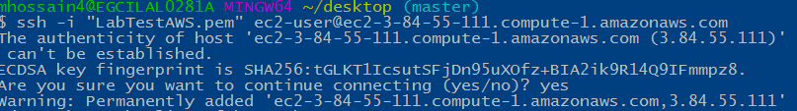

1. Type sudo su - [to become root user]



1. Type Yum update



1. Type Y when prompt Is this ok?



1. Wait until yum update complete message shown



1. Type yum install java-1.8*
2. Type Y when prompt Is this ok?



1. Wait until yum update complete message shown



1. Type which java



1. Type ls -lah /etc/alternatives/java



1. Configure java (Temporary) [ Make sure Java version you have downloaded vs below]

* Type export JAVA_HOME=/opt/jdk1.8.0_20/bin/java and hit enter
* Type export JRE_HOME=/opt/jdk1.8.0_20/bin/jre/bin/java and hit enter
* Type export PATH=$PATH:$HOME/bin:JAVA_HOME:JRE_HOME and hit enter
* echo $JAVA_HOME

/opt/jdk1.8.0_20/bin/java

* echo $JRE_HOME

/opt/jdk1.8.0_20/bin/jre/bin/java

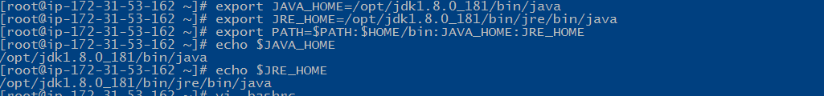

1. Type cd /home
2. Type java –version



1. Type useradd jenkins-slave02 [Sornali slave02 Rabbi slave03 Malik slave04]



1. Type sudo su - jenkins-slave02



1. Type ssh-keygen -t rsa -N "" -f /home/jenkins-slave02/.ssh/id_rsa and hit Enter for each prompt if appears

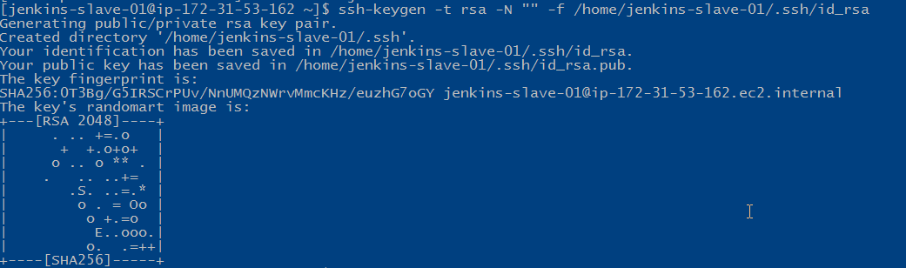

1. Type cd .ssh
2. Type cat id_rsa.pub > authorized_keys
3. Type chmod 700 authorized_keys
4. Type more id_rsa



1. Copy the file to a notepad

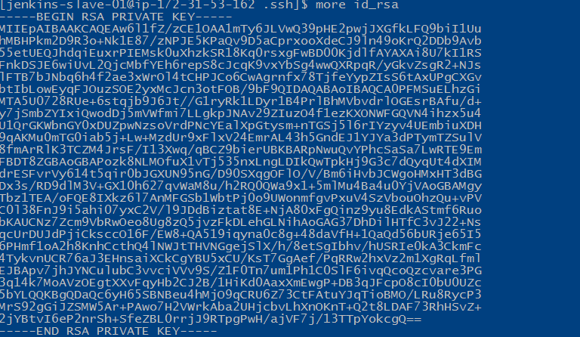

1. Permanent single user [optional exercise]
2. Type vi ~/.bashrc
3. Hit ‘I” in keyboard and End of the file paste the below 3 lines, hit Esc key, and Shift+: and then type: wq to save the file [check the Java version you downloaded vs below]

export JAVA_HOME=/opt/jdk1.8.0_20/bin/java

export JRE_HOME=/opt/jdk1.8.0_20/jre/bin/java

export PATH=$PATH:$HOME/bin:JAVA_HOME:JRE_HOME

1. Type source ~/.bashrc
2. Type echo $JAVA_HOME

/opt/jdk1.8.0_20/bin/java

1. echo $JRE_HOME

/opt/jdk1.8.0_20/jre/bin/java

1. Type yum install wget
2. Install Maven Type wget [http://repos.fedorapeople.org/repos/dchen/apache-maven/epel-apache-maven.repo -O /etc/yum.repos.d/epel-apache-maven.repo](http://repos.fedorapeople.org/repos/dchen/apache-maven/epel-apache-maven.repo%20-O%20/etc/yum.repos.d/epel-apache-maven.repo)
3. Type sed -i s/\$releasever/6/g /etc/yum.repos.d/epel-apache-maven.repo
4. Type yum install -y apache-maven
5. Type mvn –v
6. Type yum install git
7. Type git --version

**********************Student SKIP***************************************************

Permanent all user [skip above 13-18] [optional exercise]

1. Type vi /etc/profile

JAVA_HOME="/usr/lib/jvm/java-7-openjdk-amd64/bin/java"

JRE_HOME="/usr/lib/jvm/java-7-openjdk-amd64/jre/bin/java"

PATH=$PATH:$HOME/bin:JAVA_HOME:JRE_HOME

1. Type . /etc/profile
2. Type echo $JAVA_HOME

/usr/lib/jvm/java-7-openjdk-amd64/bin/java

1. Type echo $JRE_HOME

/usr/lib/jvm/java-7-openjdk-amd64/jre/bin/java

1. Create user and add the user to wheel group

Type useradd jenkins-slave-002

1. Create SSH Keys

Type sudo su - jenkins-slave-002

1. Type ssh-keygen -t rsa -N "" -f /jenkins-slave-002/.ssh/id_rsa
2. The private and public keys will be created at these locations `/home/jenkins-slave-01/.ssh/id_rsa` and `/home/jenkins-slave-01/.ssh/id_rsa.pub`
3. cd .ssh
4. cat id_rsa.pub > authorized_keys
5. chmod 700 authorized_keys

******************************** Student SKIP****************************************

**************Example of transaction 1-28 steps at the bottom*******************************

Configuration on Master

1. Login to **Master Jenkins** and then mange jenkins>manage node>New node and information as shown

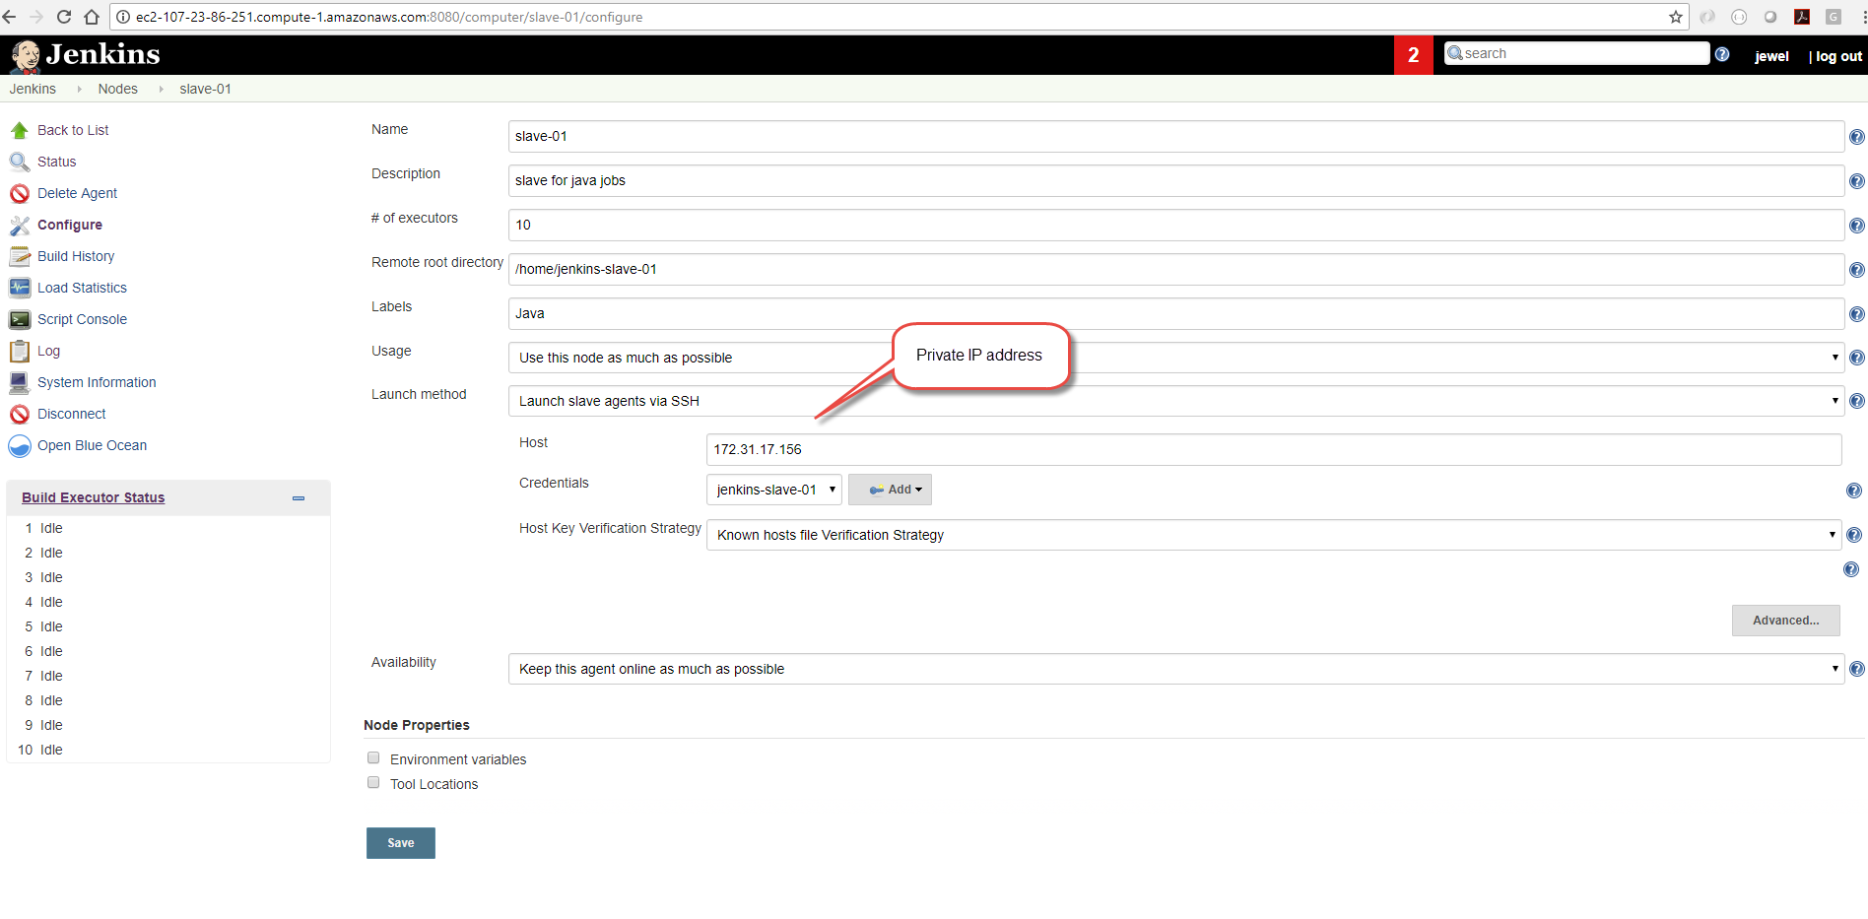

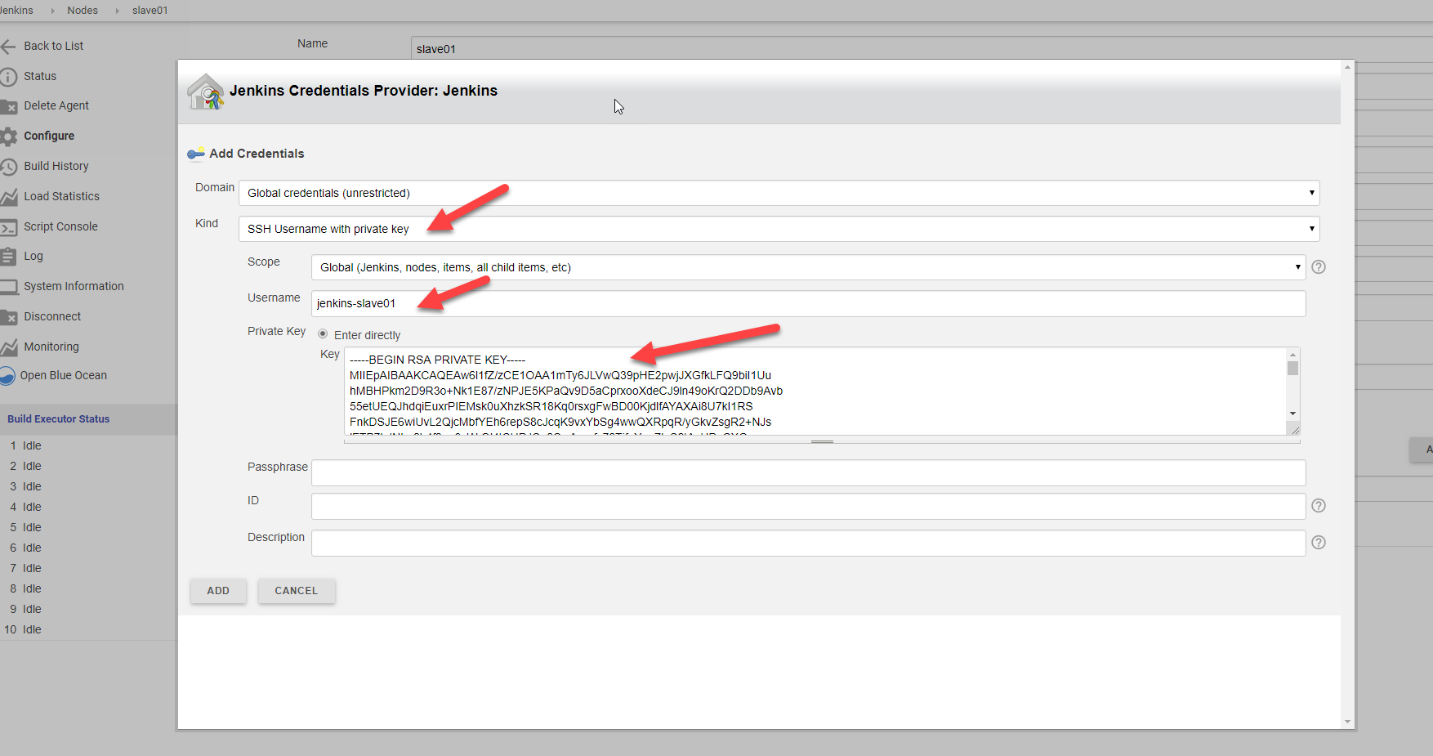

1. See above section for below and paste the key from notepad step 22
2. Login to **Jenkins Master sever** [Linux] as a root

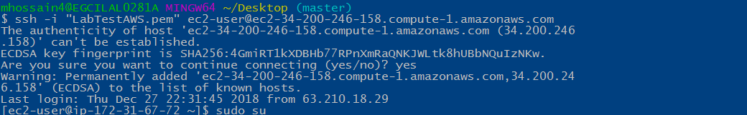

1. Type sudo -u jenkins ssh-keygen and overwrite the file [hit enter without entering any information] [SKIP]

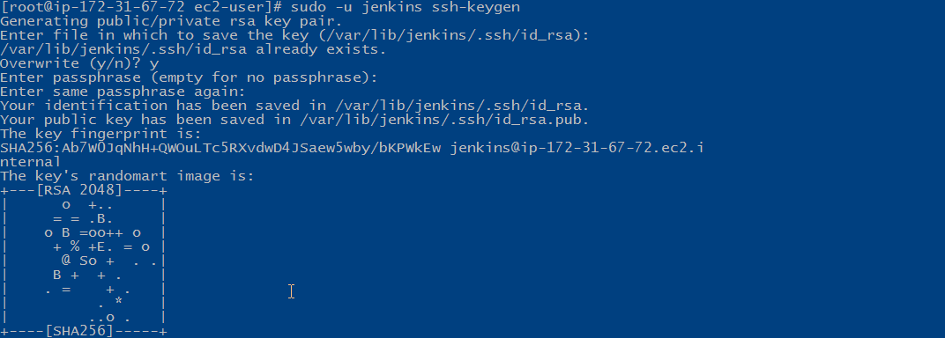

1. Copy the slave node's public key[id_rsa.pub] to Master Node's known_hosts file

Type mkdir -p /var/lib/jenkins/.ssh

1. Type cd /var/lib/jenkins/.ssh
2. Type ssh-keyscan -H SLAVE-NODE-IP-OR-HOSTNAME >>/var/lib/jenkins/.ssh/known_hosts

Example: ssh-keyscan -H 172.31.38.42 (private IP) >>/var/lib/jenkins/.ssh/known_hosts

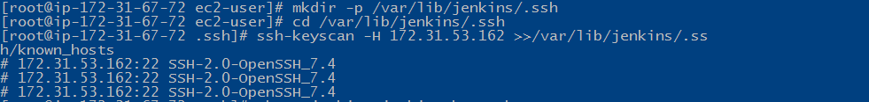

1. Type chown jenkins:jenkins known_hosts
2. Type chmod 700 known_hosts



*******************Example**********************************

[root@ip-172-31-67-72 jenkins]# cd .ssh

[root@ip-172-31-67-72 .ssh]# mkdir -p /var/lib/jenkins/.ssh

[root@ip-172-31-67-72 .ssh]# cd /var/lib/jenkins/.ssh

[root@ip-172-31-67-72 .ssh]# ssh-keyscan -H 172.31.17.156 >>/var/lib/jenkins/.ssh/known_hosts

# 172.31.17.156:22 SSH-2.0-OpenSSH_7.4

# 172.31.17.156:22 SSH-2.0-OpenSSH_7.4

# 172.31.17.156:22 SSH-2.0-OpenSSH_7.4

[root@ip-172-31-67-72 .ssh]#

**********************************************************************

1. Launch the agent

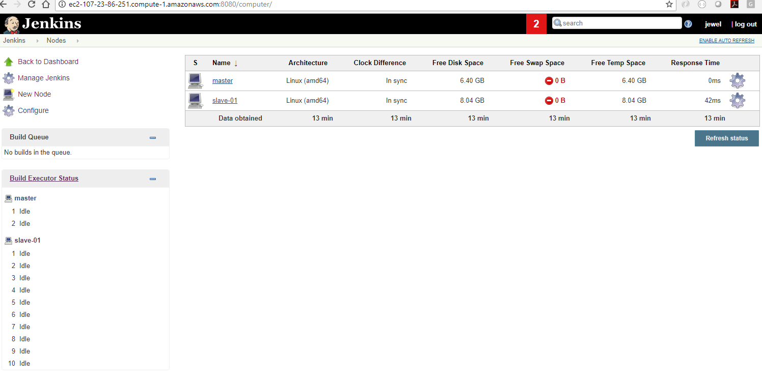

1. Open the node configurations and the path

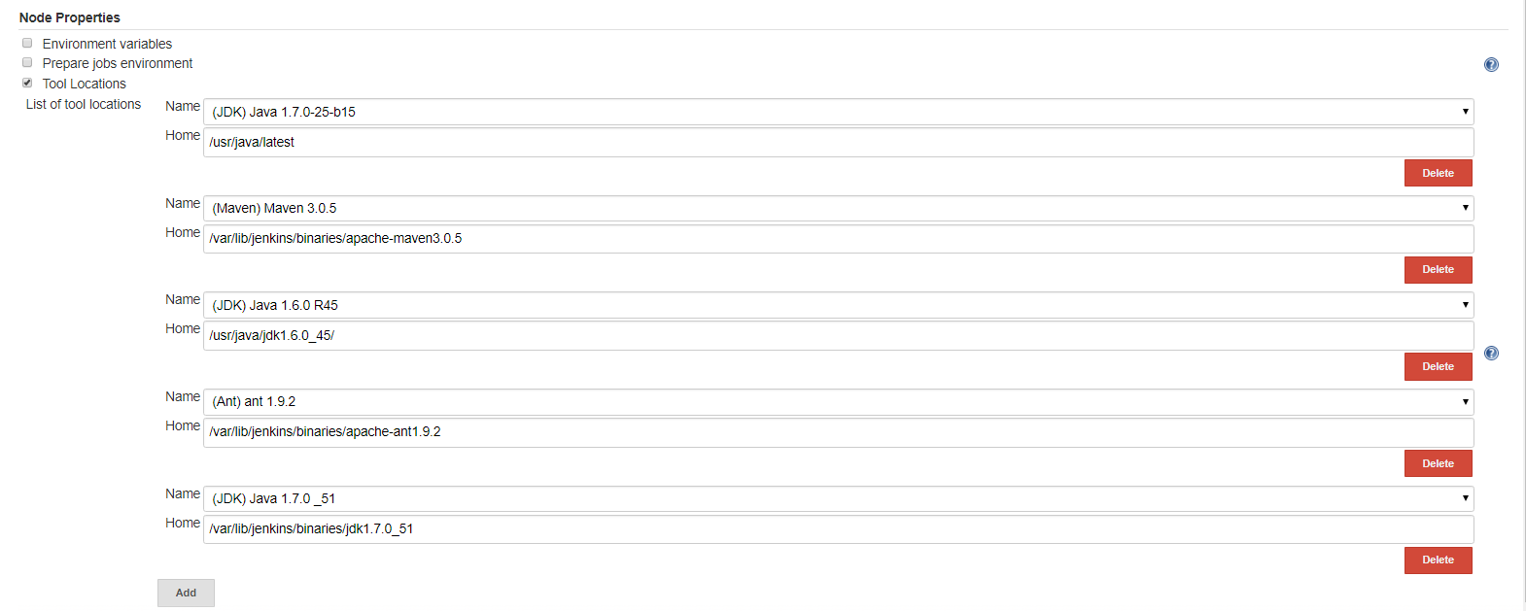

**Test Jenkins Jobs**

1. Create “new item”
2. Enter an item name – My-First-Project
3. Chose Freestyle project and click OK
4. Next Under General Section

Choose Restrict where this project can be run

1. Update your jenkins slave label Java

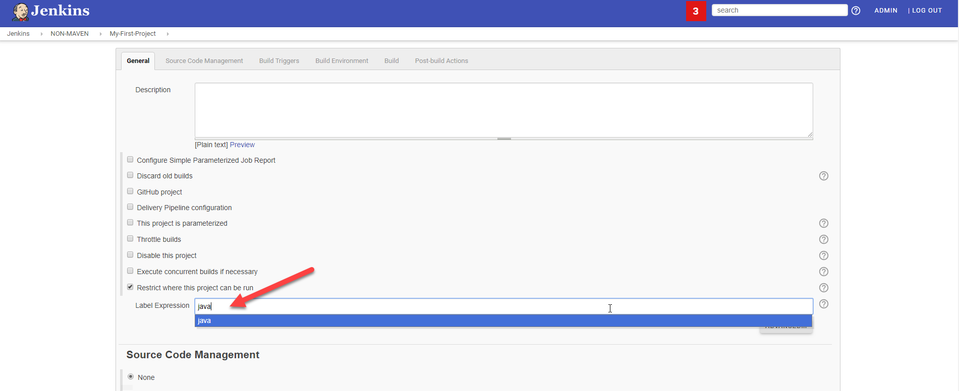

1. Under Build section Execute shell (paste the whole thing)

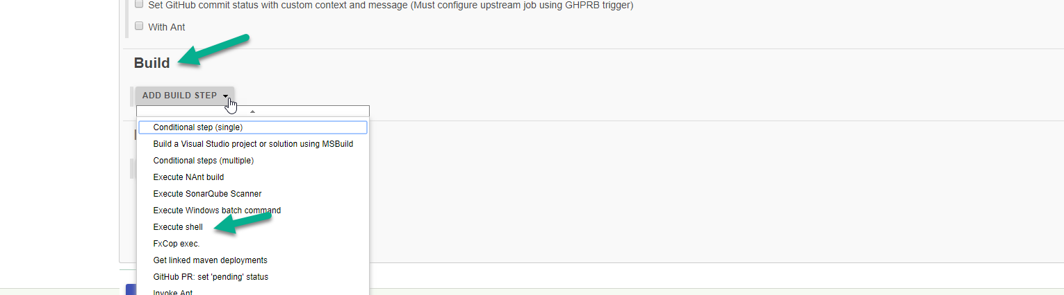

#!/bin/bash

echo "_______________________________"

echo "| |"

echo "| Welcome to Valaxy Demo |"

echo "| _nnnn_ |"

echo "| dGGGGMMb |"

echo "| @p~qp~~qMb |"

echo "| M|@||@) M| |"

echo "| @,----.JM| |"

echo "| JS^\__/ qKL |"

echo "| dZP qKRb |"

echo "| dZP qKKb |"

echo "| fZP SMMb |"

echo "| HZM MMMM |"

echo "| FqM MMMM |"

echo "| __| '. |\dS'qML |"

echo "| | '. | ' \Zq |"

echo "| _) \.___.,| .' |"

echo "| \____ )MMMMMP| .' |"

echo "| '-' '--' hjm |"

echo "_______________________________"

1. Save your job
2. Build job
3. Check "console output"

Example:

Step 